MySQL JOINS

MySQL JOINS are used with SELECT statement. It is used to retrieve data from multiple tables. It is performed whenever you need to fetch records from two or more tables.

There are three types of [MySQL](https://www.javatpoint.com/mysql-tutorial) joins:

* MySQL INNER JOIN (or sometimes called simple join)
* MySQL LEFT OUTER JOIN (or sometimes called LEFT JOIN)
* MySQL RIGHT OUTER JOIN (or sometimes called RIGHT JOIN)

MySQL Inner JOIN (Simple Join)

The [MySQL INNER JOIN](https://www.javatpoint.com/mysql-inner-join) is used to return all rows from multiple tables where the join condition is satisfied. It is the most common type of join.

**Syntax:**

1. **SELECT** columns
2. **FROM** table1
3. **INNER** JOIN table2
4. **ON** table1.**column** = table2.**column**;

**Image representation:**

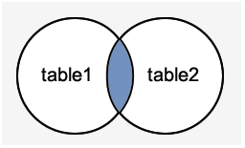

**Let's take an example:**

Consider two tables "officers" and "students", having the following data.

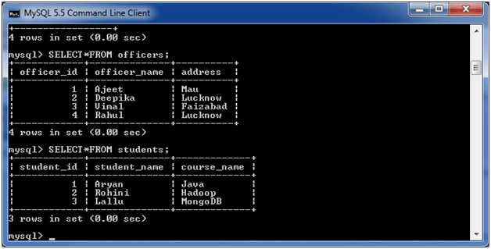

**Execute the following query:**

1. **SELECT** officers.officer_name, officers.address, students.course_name
2. **FROM** officers
3. **INNER** JOIN students
4. **ON** officers.officer_id = students.student_id;

**Output:**

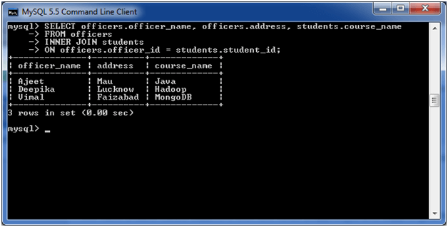

MySQL Left Outer Join

The LEFT OUTER JOIN returns all rows from the left hand table specified in the ON condition and only those rows from the other table where the join condition is fulfilled.

**Syntax:**

1. **SELECT** columns
2. **FROM** table1
3. LEFT [OUTER] JOIN table2
4. **ON** table1.**column** = table2.**column**;

**Image representation:**

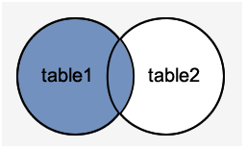

**Let's take an example:**

Consider two tables "officers" and "students", having the following data.



**Execute the following query:**

1. **SELECT**  officers.officer_name, officers.address, students.course_name
2. **FROM** officers
3. LEFT JOIN students
4. **ON** officers.officer_id = students.student_id;

**Output:**

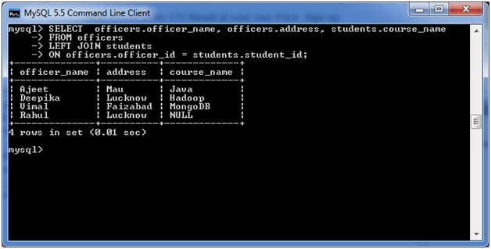

MySQL Right Outer Join

The MySQL Right Outer Join returns all rows from the RIGHT-hand table specified in the ON condition and only those rows from the other table where he join condition is fulfilled.

AD

**Syntax:**

1. **SELECT** columns
2. **FROM** table1
3. RIGHT [OUTER] JOIN table2
4. **ON** table1.**column** = table2.**column**;

**Image representation:**

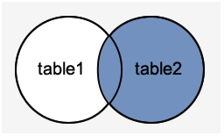

**Let's take an example:**

Consider two tables "officers" and "students", having the following data.



**Execute the following query:**

AD

1. **SELECT** officers.officer_name, officers.address, students.course_name, students.student_name
2. **FROM** officers
3. RIGHT JOIN students
4. **ON** officers.officer_id = students.student_id;

**Output:**

